Email Template

Do you need a sample email to send to co-workers, friends, and family to tell them about City Harvest’s Skip Lunch Fight Hunger? Copy, paste and fill in the blank fields below to create a personalized message and help simplify your fundraising!

Feel free to add any personal touches about why you and/or your company are getting involved with City Harvest and the fight against child hunger. Sharing these details can really help your message hit home.

Other things to include:

- Sharing details on your company’s matching gift program is an effective way to motivate colleagues considering a donation. Attach your company’s matching gifts form to your email as a reminder, or if your company uses an online portal, include that link. If you’re unsure on your company’s matching gift company, reach out to your Human Resources department.

- Include information about any contests or fun incentives that participants can take part in by donating to your team (department-wide competitions, raffle tickets, giveaways, free lunch, Casual Friday, etc.).

- If you’re holding events the week of Skip Lunch Fight Hunger to help fundraise (think bake sales, potlucks, catered breakfasts/lunches, happy hours, pizza parties, etc.), be sure to include those details in your email.

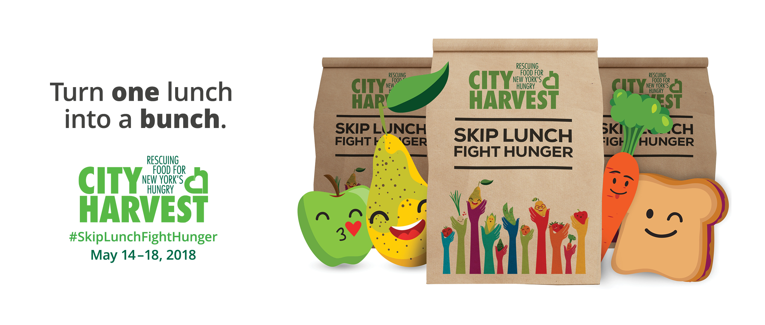

Subject: Help Feed Kids in NYC
Dear friend,
At a time when the news around us is so heavy, many of us want to find a positive way to help. By joining forces with City Harvest, we can make a real difference in the lives of our fellow New Yorkers. Did you know that in this city of nearly unlimited abundance, 1 in 5 children don’t get enough to eat? With your help, we can change this by taking part in City Harvest’s Skip Lunch Fight Hunger, a citywide campaign to help feed thousands of hungry children and their families.

With your donation, you’ll help [team name] get closer to our fundraising goal of [goal]. Every dollar helps City Harvest rescue fresh, nutritious food that would otherwise go to waste and deliver it to soup kitchens, food pantries and other community food programs for hungry kids and their families. Donating the cost of just one $15 lunch helps make 60 tummies happy.

Together we can ensure no children in our city go hungry.

- $45 helps feed 25 children for a week
- $75 helps feed 21 children for 2 weeks
- $150 helps feed 19 children for an entire month

Click here to donate to [Insert team name. Hyperlink sentence to your team page. You can create a custom URL for your team page in your participant center]

Thank you for supporting our team and joining City Harvest to help ensure no children in our city go hungry.

With sincere thanks,
[Your Name]

P.S. Pret A Manger has teamed up with City Harvest to fight child hunger! Donate $45 or more online and you will receive a special thank you voucher from Pret A Manger in June!

